Canoe Racing New Zealand

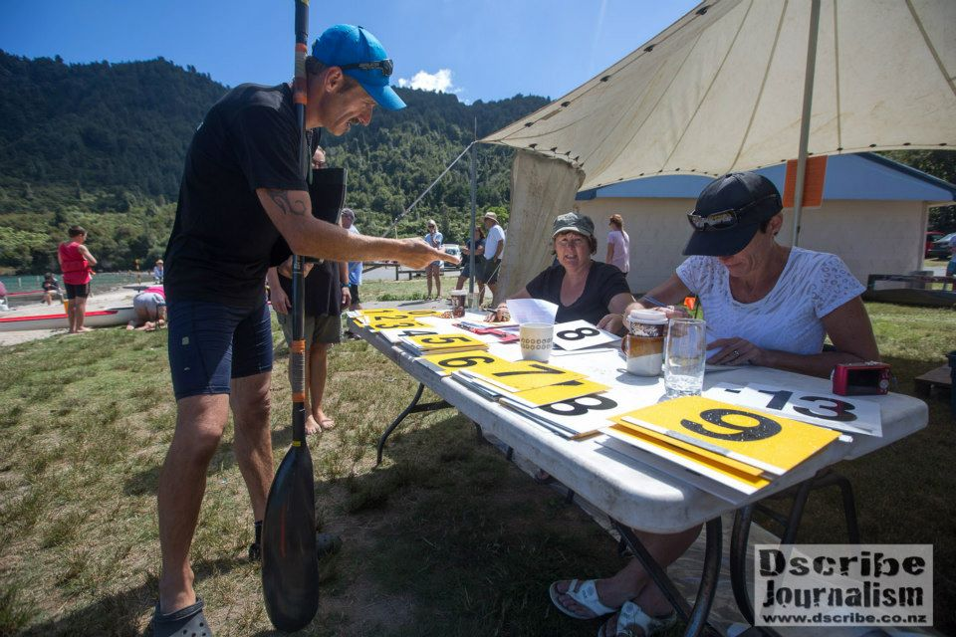

CRNZ Canoe Sprint National Official

Contents

Introduction
- Official Pathway
Community Official - Club Volunteer
National Official
ICF Continental & International Official

Module 1 – Officials philosophy and Responsibilities

- Role of the Canoe Official
- Officials Philosophy
- Key Responsibilities of the Official

Module 2 – Regatta operations and rules overview

- Regatta Management
  - Planning
  - Technical meeting
- Regatta Officials
  - Chief Official
  - Deputy Chief Official
  - Event Manager
  - Starters
  - Boat control (1 & 2)
  - Race control (polyox ID)
  - Finish Line Judge(s)
  - Results
- Rules
Read through the rule book and find the sections identified.

Regatta Experience (On the job Training)
Rotation around all positions for the regatta

- Rotation Experience
  - Boat Control
  - Race Control
  - Start & Course umpires
  - Finish line
  - Results and race committee

New Official Mentor
An experienced official will be assigned to you as a mentor for the regatta weekend. They will provide advice and answer any questions you might have.

Once you have completed the workbook and had this signed off by an accredited official you will have achieved National Official status.

INTRODUCTION

This manual is for the volunteers who serve as officials and give of their time, energy and expertise to ensure the fairest, safest possible racing conditions for all competitions.

It is for the use of Officials in the Canoe Sprint Discipline of Canoe Racing New Zealand and is based on the Canoe Racing New Zealand Canoe Sprint Racing Competition Rules, the Code of Safety for Officials, all as amended from time to time.

This manual is intended to standardize the requirements, duties and responsibilities at all levels of officiating in all stages within Canoe Racing New Zealand, to the extent possible. The intent is to build a team of proficient officials for all levels of competition. The manual will be maintained and distributed by the CRNZ management office.

In this manual, each level of officiating expertise is matched to the demands of the competition. In this way officials are qualified at levels which match their experience and ability.

CRNZ Officials Pathway

CRNZ has a three stage pathway for Officials.
- CRNZ Community Official
- CRNZ National Official
- International Canoe Federation Officials Qualification (Continental & International)

Module 1 – Officials Philosophy and Responsibilities

Read through the manual and answer the following questions:

What is role of the Canoe Sprint Official?
___________________________________________________________________________________________________________________________________________________________________________________________________________________________________________________________________________________________________________________________

What does being athlete-centered mean to you as an official?
___________________________________________________________________________________________________________________________________________________________________________________________________________________________________________________________________________________________________________________________

What is your philosophy as an official?
___________________________________________________________________________________________________________________________________________________________________________________________________________________________________________________________________________________________________________________________

Describe 5 key responsibilities of the Official?

- ______________________________________________________________________

- ______________________________________________________________________

- ______________________________________________________________________

- ______________________________________________________________________

- ______________________________________________________________________

Module 2 – Regatta operations and rules overview

Regatta Management

Planning
What are the 4 key roles of the Event Manager

- ______________________________________________________________________

- ______________________________________________________________________

- _____________________________________________________________________

- ______________________________________________________________________

Technical (Officials) Meeting
What is the purpose of the Technical Meeting?
_____________________________________________________________________________________________________________________________________________________________________________________________

What topics are covered at the Team Managers Meeting?

- ______________________________________________________________________

- ______________________________________________________________________

- ______________________________________________________________________

- ______________________________________________________________________

- ______________________________________________________________________

Regatta Officials
Give a brief description of the following roles

Chief Official
_________________________________________________________________________________________________________________________________________________________________________________________________________________________________
___________________________________________________________________________
Deputy Chief Official
_________________________________________________________________________________________________________________________________________________________________________________________________________________________________
___________________________________________________________________________

Event Manager
_________________________________________________________________________________________________________________________________________________________________________________________________________________________________
___________________________________________________________________________

Starters
_________________________________________________________________________________________________________________________________________________________________________________________________________________________________
___________________________________________________________________________

Boat control (1 & 2)
_________________________________________________________________________________________________________________________________________________________________________________________________________________________________
___________________________________________________________________________

Race control (polyox ID)
_________________________________________________________________________________________________________________________________________________________________________________________________________________________________
___________________________________________________________________________

Finish Line Judge(s)
_________________________________________________________________________________________________________________________________________________________________________________________________________________________________
___________________________________________________________________________

Results
_________________________________________________________________________________________________________________________________________________________________________________________________________________________________
___________________________________________________________________________

CRNZ Canoe Sprint Discipline – Competition Rules

Read through the Competition Rules and list below which section of the manual you would find the following rules?

Example
Question Rule # Page
- Length and weight of boats 7.2 Page 9

Questions
- Disqualifications ________ ______________ _
- Duties of Officials ________ ______________ _
- Start rules ________ ______________ _
- Paddling on the course ________ ______________ _
- NZ domestic competition age rules ________ ______________ _
- Progressions ________ ______________ _
- Boat control rules ________ ______________ _
- Entry rules ________ ______________ _
- Lane specifications ________ ______________ _
- Anti-doping rules ________ ______________ _

Regatta Experience 1 – Boat Control

What is the main purpose of Boat Control?
____________________________________________________________________________________________________________________________________________________________________________________________________________________________________________________________

What are the size and weight regulations for the following boats?

K1: Length_______________Metres Weight_____________________Kgs_

K2: Length_______________Metres Weight_____________________Kgs_

K4: Length_______________Metres Weight_____________________Kgs_

C1: Length_______________Metres Weight_____________________Kgs_

Explain the process for checking boats after racing?
___________________________________________________________________________________________________________________________________________________________________________________________________________________________________________________________________________________________________________________________
_______________________________________________________________

Explain the process if a boat you measure is under weight?
____________________________________________________________________________________________________________________________________________________________________________________________________________________________________________________________
______________________________________________________________________________________________________________________________
_______________________________________________________________

Regatta Experience 2 – Race Control

What is the main purpose of Race Control?
________________________________________________________________________________________________________________________________________________________________________________________________________________________________________________________________________________________________________________________________________________________________________________________________________________________________________________________________________________________________________________________

List 3 things you should check before a paddler goes out on the water?

- ____________________________________________________________________________________________________________________________________________
- ____________________________________________________________________________________________________________________________________________
- ____________________________________________________________________________________________________________________________________________

What do you do if a boat does not come through Race Control in time?
___________________________________________________________________________________________________________________________________________________________________________________________________________________________________________________________________________________________________________________________

List 3 safety considerations you should check before a paddler enters the water?

- ____________________________________________________________________________________________________________________________________________
- ____________________________________________________________________________________________________________________________________________
- ____________________________________________________________________________________________________________________________________________

Regatta Experience 3 – Starting and Course Umpires

What is the process used for starting a race?
_______________________________________________________________________________________________________________________________________________________________________________________________________________________________________________________________________________________________________________________________________________________________________________________________________________________________________________________________________________________________________________________________________________________________________________________

What are the start instructions?

Pre-Race ___________________________________________________________________________

Start calls: ________________ ______________ __________________

What is a false start and what do you do in the event of a false start?
___________________________________________________________________________________________________________________________________________________________________________________________________________________________________________________________________________________________________________________________

What is the role of the course umpire?
______________________________________________________________________________________________________________________________

What safety considerations do starters and course umpires need to be aware of for themselves and the athletes?
______________________________________________________________________________________________________________________________
_______________________________________________________________
_______________________________________________________________
______________________________________________________________________________________________________________________________

Regatta Experience 4 – Finish Line

What is the main purpose of Finish Line Officials?
_____________________________________________________________________________________________________________________________________________________________________________________________
_______________________________________________________________
_______________________________________________________________

What are the main tasks of the following positions?

Video Capture
____________________________________________________________________________________________________________________________________________________________________________________________________________________________________________________________________________________________________________

Video Analysis
____________________________________________________________________________________________________________________________________________________________________________________________________________________________________________________________________________________________________________

Results/Progressions
____________________________________________________________________________________________________________________________________________________________________________________________________________________________________________________________________________________________________________

Finish line judges
____________________________________________________________________________________________________________________________________________________________________________________________________________________________________________________________________________________________________________

Explain what happens if the video system fails
____________________________________________________________________________________________________________________________________________________________________________________________________________________________________________________________________________________________________________

What safety considerations do finish line officials need to be aware of for the athletes?
_________________________________________________________________________________________________________________________________________________________________________________________________________________________________
___________________________________________________________________________

Regatta Experience 5 – Competition Committee

Who is the Competition Committee?
______________________________________________________________________________________________________________________________

What is the main purpose of the Competition Committee?
_____________________________________________________________________________________________________________________________________________________________________________________________

What safety considerations does the Competition Committee need to be aware of?
______________________________________________________________________________________________________________________________

What is the process for considering a protest?
_____________________________________________________________________________________________________________________________________________________________________________________________

Name 6 things an athlete can be disqualified for at a regatta, what is the penalty?

- ____________________________________________________________________________________________________________________________________________
- ____________________________________________________________________________________________________________________________________________
- ____________________________________________________________________________________________________________________________________________
- ____________________________________________________________________________________________________________________________________________
- ____________________________________________________________________________________________________________________________________________
- ____________________________________________________________________________________________________________________________________________

CRNZ National Official – Candidate completion sheet

Name: _______________________________________________

Address: _____________________________________________________________________________________________________________________________________________________________________________________________

Email: ________________________________________________

Phone: ________________________________________________

Club: ____________________________________

Completed CRNZ Official Date
(name & signature)

Module 1: Y/N _____________________________ _______
Module 2: Y/N _____________________________ _______

Regatta Experience:

Boat Control Y/N _____________________________ _______
Race Control Y/N _____________________________ _______

Start & Course umpires Y/N _____________________________ _______

Finish line and Results Y/N _____________________________ _______

Competition Committee Y/N _____________________________ _______

On completion the candidate will have fulfilled all requirements and been accredited as a CRNZ level 1 Canoe Official.

Signed Chief Official: ____________________________ Date: _____________

Signed Candidate: ____________________________ Date: _____________

This page will be removed from the workbook and sent to CRNZ and the new official will be entered into the CRNZ database.

